**Assignment -1**

Python Programming

|  |  |
| --- | --- |
| Assignment Date | 16 September 2022 |
| Student Name | BALA KRISHNAN V |
| Student Roll Number | 113219041016 |
| Maximum Marks | 2 Marks |

Question-1:

Split this string

|  |
| --- |
| **Solution:** |
| s = "Hi there Sam!"  a=s.split()  print (a) |

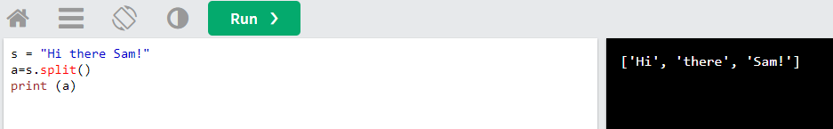

Question-2:

Use .format() to print the following string.

Output should be: The diameter of Earth is 12742 kilometers.

|  |
| --- |
| **Solution:** |
| planet **=** "Earth" diameter **=** 12742  print("The diameter of {} is {} kilometers."**.**format(planet,diameter)) |

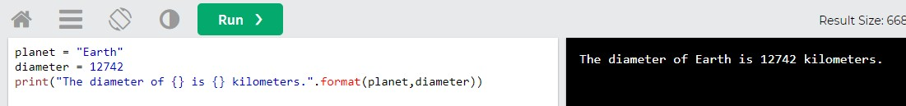

Question-3:

In this nest dictionary grab the word "hello"

**Solution:**

d**=**{'k1':[1,2,3,{'tricky':['oh','man','inception

',{'target':[1,2,3,'hello']}]}]}

a=d['k1'][3]['tricky'][3]['target'][3]

print(a)

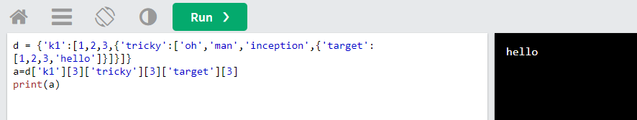

Question-4:

NUMPY

4.1- Create an array of 10 zeros?

**Solution:**

import numpy as np a=np.zeros(10) print(a)

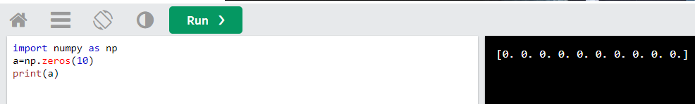

4.2 Create an array of 10 fives?

**Solution:**

import numpy as np a=np.ones(10)*5 print(a)

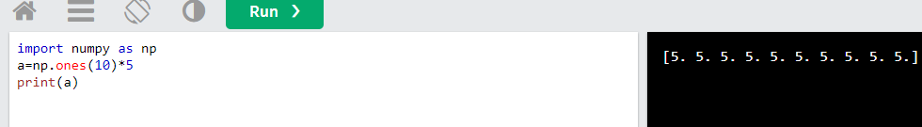

1. **Create an array of all the even integers from 20 to 35**

**Solution:**

import numpy as np a=np.arange(20,35,2) print(a)

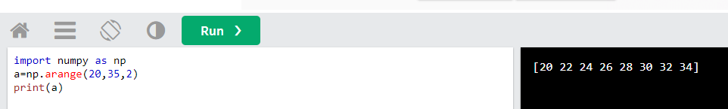

1. **Create a 3x3 matrix with values ranging from 0 to 8**

**Solution:**

import numpy as np a=np.arange(0,9).reshape(3,3) print(a)

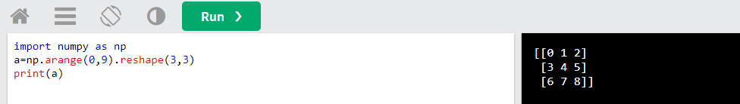

1. **Concatenate a and b**

a = np.array([1, 2, 3]), b = np.array([4, 5, 6])

**Solution:**

import numpy as np a = np.array([1, 2, 3])

b = np.array([4, 5, 6]) c=np.concatenate((a,b)) print(c)

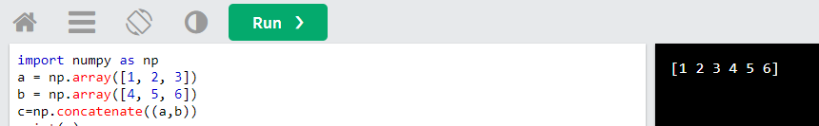

Pandas

1. **Create a dataframe with 3 rows and 2 columns**

**Solution:**

import pandas as pd

a = {'col': [6,7,9],'col_1': [2,3,0]}

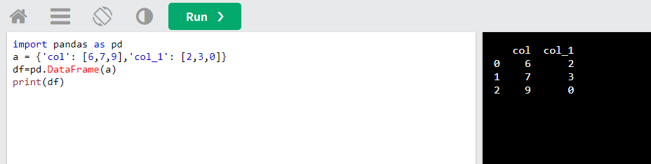df=pd.DataFrame(a) print(df)

1. **Generate the series of dates from 1st Jan, 2023 to 10th Feb, 2023**

**Solution:**

import pandas as pd

date=pd.date_range(start='01-01-2023',end='10- 02-2023')

print(date)

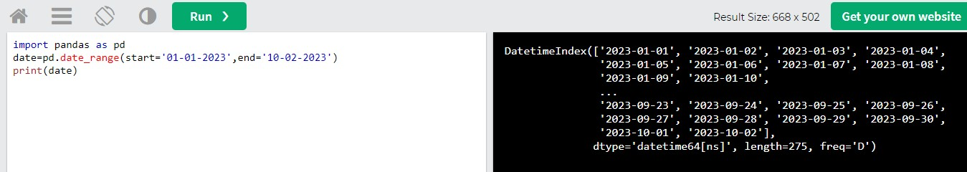

1. **Create 2D list to DataFrame**

lists = [[1, 'aaa', 22], [2, 'bbb', 25], [3, 'ccc', 24]]

**Solution:**

import pandas as pd

lists = [[1, 'aaa', 22], [2, 'bbb', 25], [3, 'ccc', 24]] df=pd.DataFrame(lists)

print(df)

